## Chapter 4: Diurnal and seasonal multi-omic integration with physiological data.

In the last two chapters, biological rhythms described by proteins and mRNAs have been deeply analyzed and discussed. One of the main results has been the observed temporal offset between transcripts and proteins, which has shown the relevance of multi-omic integration to unveil the complete molecular mechanisms of interest. Since it is the main goal of this thesis, the integration of physiological measurements with multi-omic data is presented as the final step to deeply understand how biological processes are regulated by diurnal and seasonal cycles.

### Cell Division Cycle (CDC) of *Ostreococcus tauri* under diurnal and seasonal cycles

Cell division cycle is an ordely set of processes that control the proliferation of cells (from unicellular organisms division to tissue renewal) and it is highly conserved through eukaryotes. The influence of diurnal cycles upon cell division have been studied in a wide range of phyla, from plants and microalgae like *Chlamydomonas, Euglena* and *Gonyaulax* (Bruce, 1970; Edmunds & Laval-Martin, 2019; Fung-Uceda et al., 2018; Homma & Hastings, 1989)⁠ to mice and humans (Fu et al., 2005; Matsuo et al., 2003)⁠. However, the confirmation that circadian regulation controls cell division has been a controversy topic in some organisms, such as one of the main microalgae model organisms, *Chlamydomonas reinhardtii.* While some studies concluded that cell division cycle of this microalgae was under circadian regulation (Bruce, 1970)⁠, some other concluded that the daily periodicity observed was caused by a cyclic energy status linked to the circadian regulation of photosynthesis (Spudich & Sager, 1980)⁠. Nowadays it is known that this biological rhythm present evidences of being directly regulated by the clock, as usually persist in free-running conditions and is able to be entrained by different photoperiods independent of the photosynthetic capacity. Cell division cycle has a complex regulatory mechanism consist of a strong circadian clock regulation as well as a light-dependence, since it is the main energy source in photosynthetic organisms (Goto & Johnson, 1995; Hagiwara et al., 2002; Moulager et al., 2007, 2010)⁠. This is in agreement with the RNA-seq data of this thesis. Furthermore, *Ostreococcus tauri* transcriptome seems to accomplish these characteristics. As it was mentioned in Chapter 2, its DNA replication genes need a light input to maintain rhythmicity under free-running conditions (ANEXO). Cell division cycle of *Ostreococcus* consists of the typical phases of a simple binary fission. G1 phase is dependent on light-energy status. During this phase, the cell grows and commitment takes place (Moulager et al., 2007)⁠. In cell division cycle studies, the term commitment refers to the moment when the cell, taking into consideration its energy status, decides whether is ready or not to continue with the progression of the cell division cycle. Once cells are committed, cell division is not impaired by darkness. If commitment is achieved, G1 phase is followed by the S phase, where DNA replication takes place. S phase is usually gated several hours after sunrise (Moulager et al., 2007, 2010)⁠. Once DNA replication is completed, cells enter to G2|M phase where they prepare themselves for cell division (G2) and achieve mitosis (M). This two last phases are usually treated as one because they are the shortest ones and, thus, the most difficult to detect and discern. In all eukaryotes, the progression of cells throughout the phases of the cell division cycle is controlled by cyclins and cyclin dependent kinases (CDKs). *Ostreococcus tauri* has got a extremely reduced set of cyclins and CDKs, presenting only a single copy of each gene (Robbens et al., 2005)⁠. Also, in *Ostreococcus* genome are found a canonical cell division control protein 25 (CDC25), which is not present in plants (Khadaroo et al., 2004)⁠, and a plant-specific CDKB (Corellou et al., 2005)⁠.

In the previous chapters, genes and proteins involved in DNA replication (S phase) have been highlighted in several analyses. Specifically, DNA replication is one of the enriched processes in the set of genes that need a light input to maintain rhythmicity, as well as one of the processes with the shortest time between gene expression and translation. Those results from multi-omics analyses are integrated with physiologic data in this chapter. This integration unveil the adaptation of the cell division cycle of *Ostreococcus* to different seasons and contributes to dissect the molecular mechanisms of circadian regulation of cell division in microalgae.

#### Temporal program of cell division cycle under summer and winter photoperiod

The phases from the cell division cycle have been detected by estimating the DNA content of cells, using flow cytometry, and chloroplast division observed under the fluorescence microscope, as described in Materials and Methods. The same rhythmicity analysis carried out with the transcriptomic and proteomic data, is also achieved using cytometry data, generated from the three days in a row under light-dark cycles.

Under summer photoperiod, G1, S and G2|M phases present significant rhythmic profiles with p-values of 2.96x10-6, 3.84x10-4 and 0.017, respectively. Whereas under winter photoperiod, only G1 and S phases present significant rhythmic profiles with p-values of 3.08x10-3 and 0.067, respectively. In agreement with transcriptomic and proteomic analyses, a decrease in synchronization, manifested as a reduction in amplitude, is observed under winter photoperiod (Fig 33-A). The reduction in amplitude is so drastic in the G2|M phase that RAIN programe is not able to detect a rhythmic profile. This suggest that cell division cycles of each individual cell in the culture are more synchronized during summer photoperiod. Also, there is a significant anticipation of the phase, suggesting that cell division cycle is shifted ~4h between seasons as well as a lower percentage of committed cells under winter photoperiod. (añadir boxplot mostrando estas diferencias?)

The mean percentage of cells involved in G1, S and G2|M phases are calculated for each time point. These data are used to illustrate a temporal program of the cell division cycle of Ostreococcus under both photoperiods (Fig. 33- B,C). Under summer photoperiod, G1 phase takes place during the light hours, the maximum percentage of cells in this phase are detected around ZT8 (coinciding with the maximum irradiance hours). After commitment, the percentage of cells in G1 phase decreases while the percentage of cells in S phase increases. The majority of cells are in S phase around and after sunset (between ZT16 and ZT20). From that moment, the percentage of cells in G2|M phase increases gradually as they successfully duplicate its DNA. The transition from G2|M to G1, which indicates that cell division has been achieved, takes place around ZT4. This suggest that cell division in Ostreococcus takes place after sunrise in summer (Fig. 33-B).

Under winter photoperiod, in agreement with what has been observed in summer photoperiod, G1 phase coincide with the maximum irradiance hours (corresponding to ZT4 in this photoperiod) and the S phase takes place 4h hours after sunset (corresponding to ZT8 in this photoperiod). However, the G2|M phase presents not only an adjustment to the photoperiod, but a reorganization in order to anticipate the small number of light hours ahead. During winter photoperiod, G2|M phase takes place only during the night. Right when the sun rises, cell division is achieved so cells are ready to grow during the morning. It suggest that cell division cycle is strongly influenced by the circadian clock and can anticipate cyclic changes like the short time of light in winter photoperiod. To anticipate it, the circadian clock ensures that all cells enter G1 phase right during sunrise so any hour of light is wasted (Fig. 33-A). This anticipation is also observed in chloroplast division. Under summer photoperiod, chloroplast duplication is achieved during the last part of the night (ZT20) (Fig. 33-D) and during ZT16 under winter photoperiod. Before sunrise, there are already a substantial number of cells with only one chloroplast during winter photoperiod (Fig. 33-E).

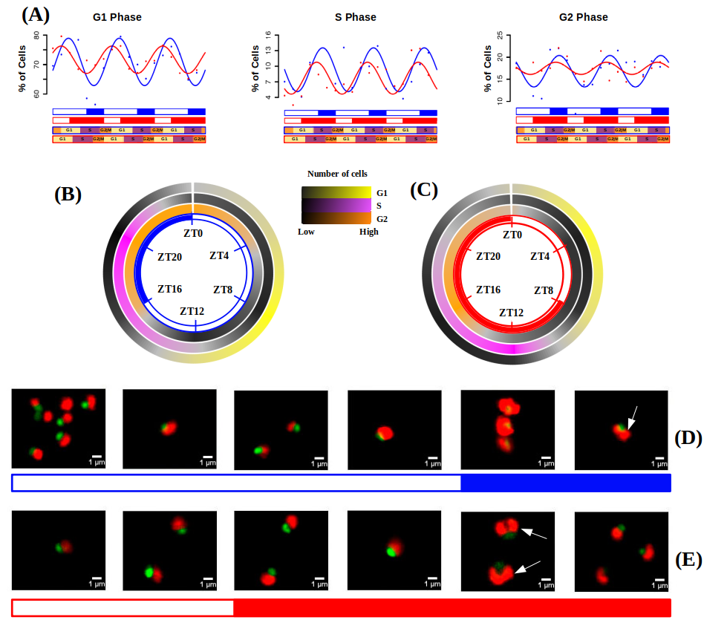Figure 33. **Cell division cycle of Ostreococcus tauri under summer and winter photoperiod.** (A) Percentage of cells in G1, S and G2|M phases during the three days of sampling. Points correspond to real data and lines represent wave´s approximations made by Circacompare during the rhythmicity analysis. (B-C) Circular heatmap representing mean percentage of cells in G1, S and G2|M phases during summer and winter photoperiod, respectively. (D-E) Photographs of cells under the fluorescence microscope. Each picture correspond to a different time point of summer and winter photoperiod, respectively. Nucleus are dyed and they fluorescence in green, chloroplast in red.

#### Integration of cell division program with transcriptomic and proteomic data.

*Ostreococcus tauri* annotated genes involved in cell division cycle are organized in three different groups in order to mark in which phase of the cell cycle they are present. This organization is represented in ANEXO (meter en anexo o aquí como tabla?) following the current cell cycle model in plants (Carneiro et al., 2021)⁠.

Cyclin A and CDKA are transcribed and translated during G1, thus, they are considered as proteins related to G1 phase which are needed to enter to S phase. Transcription factors like E2F and Dp as well as other proteins (Rb, cell division control protein 6 and ORCs) also act during G1 phase regulating the activation of genes related to the S phase. Cyclin B and CDKB transcript/proteins levels are maintained during the S phase, in conjunction with the generation of polymerases and replication related proteins (MCM complexes, replication factors, PCNA, primases, helicases, ligases, etc). Finally, Cyclin D marks the beginning of G2|M phase as well as subunits of the anaphase-promoting complex (APC) and cell division control proteins (CDC20 and CDC25) (Moulager et al., 2007, 2010; Robbens et al., 2005)⁠.

Gene expression and protein abundance profiles are compared with the % of cells in the phase of the cycle they are involved in (Fig. 34). Besides the gene-protein offset, a general offset between protein abundance and the execution of their physiological role is observed. This offset is longer in phases as G1 or G2 (Fig. 34- A,C). During the S phase, as soon as the proteins are available, the biological process is executed (Fig. 34- B). It could be explained by the experimental design followed, since proteins selected are directly involved in DNA replication and flow cytometry directly estimates cell division phases based in the DNA content of populations.

The transcriptomic and proteomic data for cyclins and CDKs found in *Ostreococcus* (Fig. 35) are in agreement with the current cell cycle model for plants. For both, summer and winter photoperiods, the transcription of Cyclin A gene takes place during G1 phase and it is the first cyclin to be activated. Cyclin A is suggested to be purely regulated by the circadian clock since it has been proved to be independent of the metabolic status (Moulager et al., 2010)⁠. In agreement with previous transcriptomic analysis (Carneiro et al., 2021; Moulager et al., 2007)⁠, Cyclin A expression is followed by Cyclin B expression during the S phase (Fig 35-A).

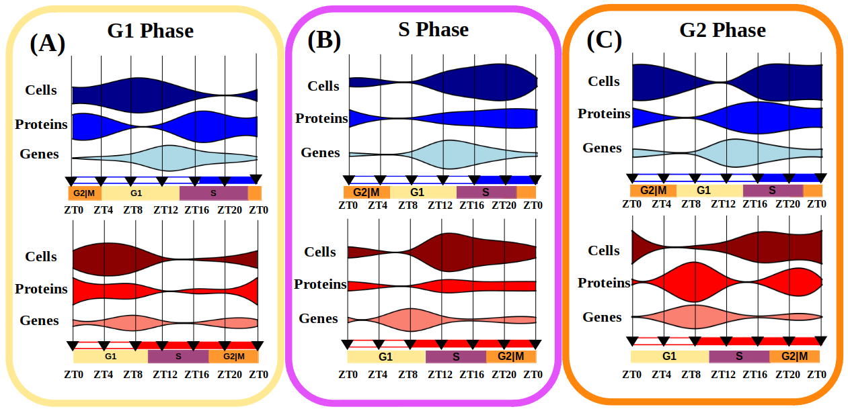Figure 34: **Integration of gene expression, protein abundance and cell population profiles for each phase of the cell cycle.** Violin plots represent the three biological levels studied: “Genes” for transcriptomic data, “Proteins” for proteomic data and “Cells” for DNA content estimation by flow cytometry. (A) Involves G1 phase related data, (B) for S phase and (C) for G2 phase.

Cyclins proteins are not detected in our proteomic analysis, however CDKA and CDKB proteins are detected and their abundance profiles are in agreement with the proposed model. CDKA transcript reaches its maximum level of expression during G1, which causes an increase of CDKA protein abundance by the second part of G1 phase (Fig. 35-B) allowing, with CyclinA, the progression of the cell cycle to the S phase. During the S phase, CDKB protein abundance level reaches its maximum (Fig. 35- C), being coincident with Cyclin B transcript. Cyclin D transcript levels are low under both photoperiods, but their maximum level of expression are coincident with G2|M phase (Fig. 35-A). Por qué sube tanto la CycA en SD?.

FTSZ transcript and protein profiles are presented in order to achieve a deeper understanding of the chloroplast division in *Ostreococcus*. FTSZ is a key protein of the chloroplast division machinery that has been conserved from its cyanobacterial ancestors (FtsZ in chloroplast division: Structure, function and evolution). Chloroplast division is considered to take place during sunrise in summer photoperiod and 4h before sunrise in winter photoperiod (Fig. 33- D,E), which is in agreement with the protein abundance profiles of FTSZ in both photoperiods (Fig. 35-D) En realidad SD no coincide muy bien no? merece la pena poner las graficas de FTSZ?

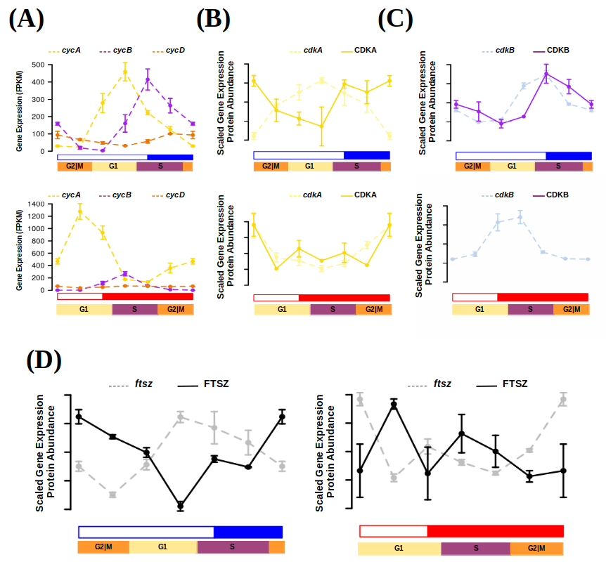Figure 35: **Transcript and protein abundance profiles of the main cell cycle proteins under summer and winter photoperiod in Ostreococcus tauri.** (A) Expression level of cyclins A (yellow.ME PARECE QUE ESTE COLOR NO ESTÁ BIEN ELEGIDO PORQUE NO SE VE CUANDO ES LA LÍNEA DISCONTINUA), B (purple) and D (orange) genes are represented with discontinued lines under summer (blue) and winter (red) photoperiods. Transcript (discontinued line) and protein (solid line) abundances of CDKA are represented in yellow (B), CDKB in purple (C ) and FTSZ in black (D).

### Diurnal and seasonal rhythm of photosynthesis in *Ostreococcus tauri*

Photosynthesis is the process that allow plants to use light as their main energy source. It consumes H2O and produces O2 (which is released to the atmosphere), ATP (which is used as energy in the main cellular processes), and NADPH (which is used as reducing agent needed in the Calvin cycle to fix CO2 from the atmosphere and synthesize carbon compounds).

In the genome of *Ostreococcus tauri*, all the essential proteins involved in photosynthesis electron transport chain and carbon fixation are present, but with a lower number of copies compared with plants and other microalgae. The light-harvesting complexes of *Ostreococcus* are singular: light-harvesting complex proteins associated with photosystem I (LHCI) are present but LHCII are lacking. Instead, a prasinophyte-specific chrolophyll-binding proteins are found (Blanc-Mathieu et al., 2014; Derelle et al., 2006)⁠. It suggest that LHCI is present in the green lineage since earlier (Six et al., 2005)⁠.

Understanding how photosynthesis is adapted to diurnal and seasonal cycles can contribute to develop systems where plant productivity is increased, which is a relevant topic in agriculture. Circadian regulation of this process was first described in marine algae, when circadian oscillations of oxygen production were observed (Dodd et al., 2014; Sweeney & Haxo, 1961)⁠. After that discovery, circadian oscillations of more physiological phenomena related to photosynthesis (such as chloroplast ATP concentration, electron transport rate, starch content or photosynthesis efficiency) have been also described in microalgae (Mackenzie & Morse, 2011; Ral et al., 2006; Sorek et al., 2013; Sweeney & Haxo, 1961)⁠. Furthermore, circadian oscillations in photosynthesis are also found in plants, even in the ones with agriculture interest (Feugier & Satake, 2013; Lonergan, 1981; Tucker et al., 2004)⁠. Nowadays, omics techniques have enable to elucidate that genes involved in photosynthesis and carbon fixation describe oscillations with a 24h period in microalgae and plants (Ferrari et al., 2019)⁠. In addition, this thesis describes for the first time how rhythmic expression profiles of the genes involved in the complete metabolic pathway are maintained under different photoperiods and free-running conditions (constant light and constant darkness) in a photosynthetic organism.

The genes involved in photosynthesis have been described as *bona fide* circadian genes in Chapter 4, since their rhythmic expression profile is maintained during both summer and winter photoperiod and free-running conditions. Moreover, in Chapter 5, photosynthesis have been found as one of the processes with the shortest offset between gene expression and translation in *Ostreococcus tauri.* Those results from multi-omics analyses are now integrated with photosynthetic efficiency measurements under both photoperiods. This integration unveils the adaptation of photosynthesis and related processes like carbon fixation and starch metabolism in *Ostreococcus* to different seasons and contributes to dissect the conserved circadian regulation mechanisms controlling photosynthetic productivity in the green lineage.

#### Rhythmic oscillations of photosynthetic efficiency under summer and winter photoperiod

Photosynthesis efficiency has been calculated by estimating chlorophyll fluorescence parameter Fv/Fm, which is used as a common measure of PSII performance. The same rhythmicity analysis carried out with the transcriptomic and proteomic data is also achieved with Fv/Fm measurements obtained from three consecutive days under light-dark cycles (summer and winter photoperiods). Data generation and analysis are described in detail in Materials and Methods.

Under summer photoperiod, Fv/Fm present a clear rhythmic profile with a 24h period, with a p-value of 3.5x107 (Fig. 36-A). The maximum value of Fv/Fm takes place periodically every 24h during the maximum irradiance hours (around ZT8). It suggests that photosystems are at their higher performance by that time of the day and, thus, photosynthetic efficiency. Whereas, under winter photoperiod, a rhythmic profile with two maxima in the Fv/Fm values is observed (Fig. 36-B). Both peaks in Fv/Fm rhythmic profile are repeated periodically every 12h with a p-value of 0.01. One peak is in agreement with the summer Fv/Fm rhythmic profile and it takes place during the maximum irradiance hours (ZT4 in winter photoperiod). The other peak corresponds to a smaller increment of Fv/Fm value that takes place more than 8h before sunrise. It means that photosynthetic machinery is prepared in anticipation during the night, as a circadian response to the few hours of light during winter photoperiod. These results suggest that *Ostreococcus tauri* is able to anticipate cyclic changes in photoperiod, which is a signal of strong circadian regulation of photosynthesis.

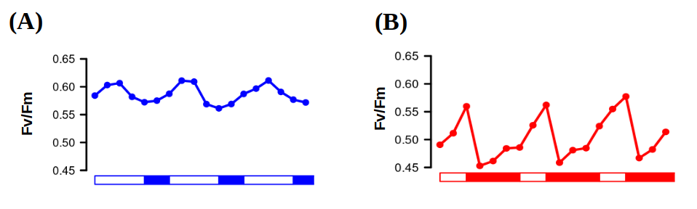Figure 36. **Photosynthetic efficiency rhythmic oscillations.** Fv/Fm oscillating values used as an estimation of PSII performance and, thus, photosynthetic efficiency under three consecutive days of summer (A) and winter (B) photoperiods.